File Backup Rsync

# Rsync 基本特性

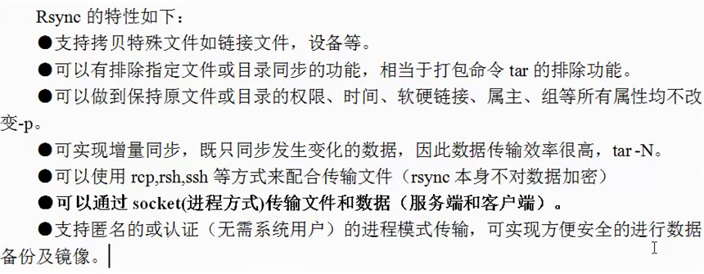

## Rsync 工作方式

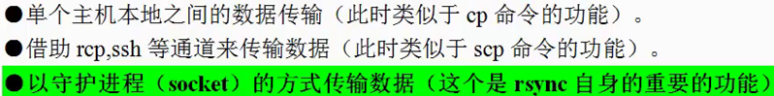

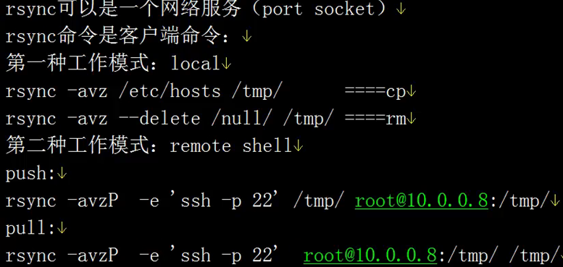 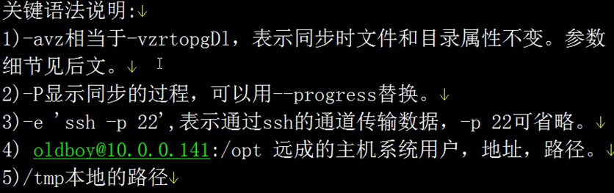 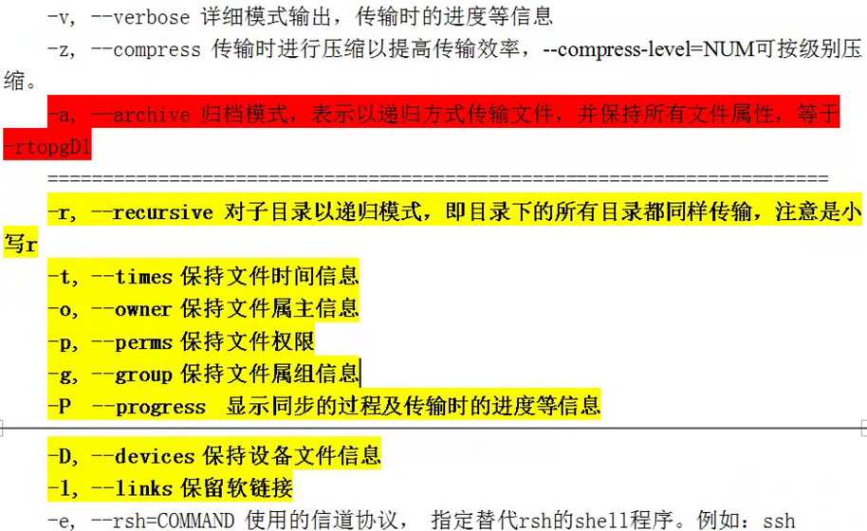

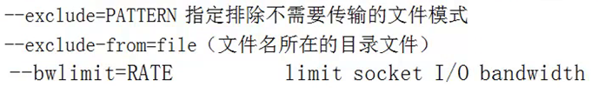



## rsync 服务器端配置

### 2.1版本号

[leo@backup-server ~]$ rsync --version

rsync version 3.0.6 protocol version 30

### 2.2创建rsync 配置文件

[root@backup-server ~]# touch /etc/rsyncd.conf

Sample:

#Rsync Server

#Created by leo

##rsyncd.conf start##

uid = rsync

gid = rsync

use chroot = no

max connections = 2000

timeout = 60

pid file = /var/run/rsyncd.pid

lock file = /var/run/rsync.lock

log file = /var/log/rsyncd.log

ignore errors

read only = false

list = false

hosts allow = 192.0.0.0/24

hosts deny = 0.0.0.0/32

auth users = rsync_backup

secrets file = /etc/rsync.password

##########################################

[www]

comment = www by leo

path = /backup

### 2.3启动服务

[root@backup-server ~]# **rsync --daemon**

[root@backup-server ~]# ps -ef|grep rsync|grep -v grep

root 1225 1 0 17:20 ? 00:00:00 rsync –daemon

[root@backup-server ~]# ss -tunlp|grep rsync

tcp LISTEN 0 5 :::873 :::* users:(("rsync",1225,5))

tcp LISTEN 0 5 *:873 *:* users:(("rsync",1225,3))

[root@backup-server ~]# netstat -tunlp|grep rsync

tcp 0 0 0.0.0.0:873 0.0.0.0:* LISTEN 1225/rsync

tcp 0 0 :::873 :::* LISTEN 1225/rsync

### 2.4创建虚拟用户

[root@backup-server ~]# useradd rsync -s /sbin/nologin -M

[root@backup-server ~]# id rsync

uid=829(rsync) gid=829(rsync) groups=829(rsync)

### 2.5 创建备份目录

[root@backup-server ~]# mkdir /backup

[root@backup-server ~]# chown -R rsync /backup/

[root@backup-server ~]# ll -d /backup/

drwxr-xr-x 2 rsync root 4096 2016-03-01 17:24 /backup/

### 2.6创建密码文件

[root@backup-server ~]# echo "rsync_backup:rsync" > /etc/rsync.password

[root@backup-server ~]# cat /etc/rsync.password

rsync_backup:rsync

[root@backup-server ~]# chmod 600 /etc/rsync.password

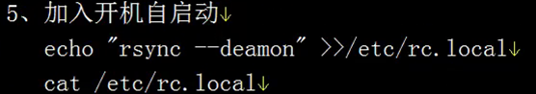

## rsync客户端配置

### 3.1 创建密码文件 只需要密码 600

[root@centos6-server1 ~]# echo "rsync">/etc/rsync.password

[root@centos6-server1 ~]# chmod 600 /etc/rsync.password

### 3.2 rsync

[root@centos6-server1 ~]# rsync -avz /tmp/ rsync_backup@192.168.137.90::backup --password-file=/etc/rsync.password

## 4.重启rsync 的组合命令

pkill rsync

killall rsync #杀到提示没有可杀的为止

kill `cat /var/run/rsyncd.pid`

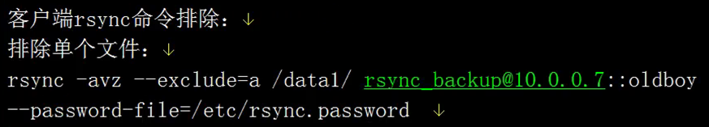

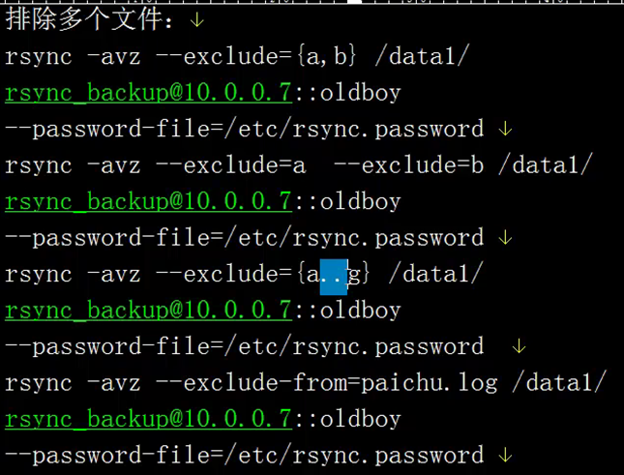

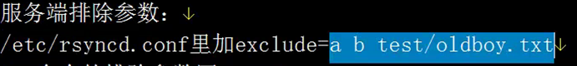

NOTE：

[root@centos6-server1 .ICE-unix]# mkdir /backup

[root@centos6-server1 .ICE-unix]# ifconfig eth0|awk -F '[ :]+' 'NR==2 {print $4}'

192.168.137.81

[root@centos6-server1 .ICE-unix]# mkdir /backup/`ifconfig eth0|awk -F '[ :]+' 'NR==2 {print $4}'`_$(date +%F) -p

[root@centos6-server1 .ICE-unix]# cp /etc/rc.local /backup/`ifconfig eth0|awk -F '[ :]+' 'NR==2 {print $4}'`_$(date +%F)/

#shell

#!/bin/sh

path=/backup

dir="`ifconfig eth0|awk -F '[ :]+' 'NR==2 {print $4}'`_$(date +%F)"

mkdir $path/$dir -p &&\

/bin/cp /etc/rc.local $path/$dir/rc.local_$(date +%F) &&\

/bin/cp /var/spool/cron/root $path/$dir/cron_root_$(date +%F) &&\

rsync -az $path rsync_backup@192.168.137.90::backup --password-file=/etc/rsync.password

# NFS 实时同步 (inotify / sersync)

## 环境准备

### 1.1 开启rsync daemon 服务

[root@backup-server ~]# lsof -i :873

COMMAND PID USER FD TYPE DEVICE SIZE/OFF NODE NAME

rsync 1305 root 3u IPv4 12364 0t0 TCP *:rsync (LISTEN)

rsync 1305 root 5u IPv6 12365 0t0 TCP *:rsync (LISTEN)

### 1.2 创建rsync 客户端

[root@centos6-server /]# echo "rsync">/etc/rsync.password

[root@centos6-server /]# chmod 600 /etc/rsync.password

[root@centos6-server /]# rsync -avz /data rsync_backup@192.168.137.90::backup --password-file=/etc/rsync.password

## 安装inotify

### 2.1查看系统是否支持

[root@centos6-server /]# uname -r

2.6.32-504.el6.x86_64 #2.6.13 及以上

[root@centos6-server /]# ll /proc/sys/fs/inotify/

total 0

-rw-r--r-- 1 root root 0 2016-03-02 18:46 max_queued_events

-rw-r--r-- 1 root root 0 2016-03-02 18:46 max_user_instances

-rw-r--r-- 1 root root 0 2016-03-02 18:46 max_user_watches

#显示以上三个文件表示支持

### 2.2 下载并安装文件

inotify-tools-3.14.tar.gz

[root@centos6-server tools]# tar zxf inotify-tools-3.14.tar.gz

[root@centos6-server tools]# cd inotify-tools-3.14

[root@centos6-server inotify-tools-3.14]# ./configure --prefix=/usr/local/inotify-tools-3.14

[root@centos6-server inotify-tools-3.14]# make && make install

[root@centos6-server ~]# ln -s /usr/local/inotify-tools-3.14/ /usr/local/inotify-tools

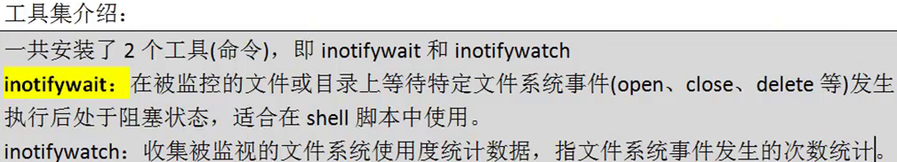

### 2.3常用参数详解

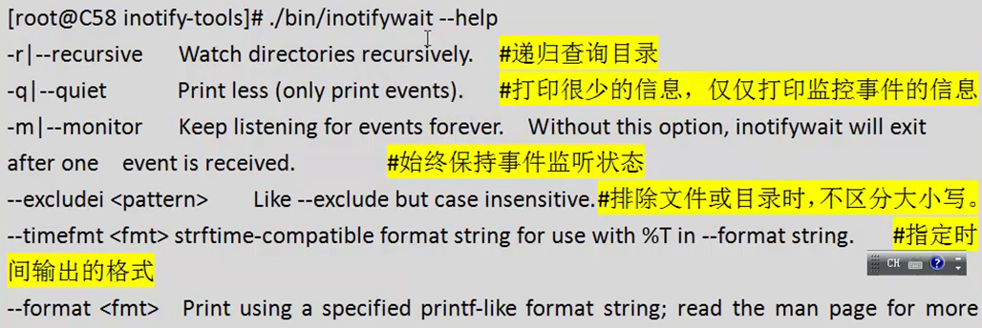

## Inotify 使用

[root@centos6-server inotify-tools]# /usr/local/inotify-tools/bin/inotifywait -mrq --timefmt '%d%m%y %H:%M' --format '%T %w%f' -e create /data #监控创建事件

监控增加，删除，修改事件：



示例脚本（监控目录变化并传输到备份服务器：）

[root@centos6-server scripts]# cat inotify.sh

#!/bin/bash

inotify=/usr/local/inotify-tools/bin/inotifywait

$inotify -mrq --timefmt '%d%m%y %H:%M' --format '%T %w%f' -e create,close_write,delete /data \

|while read file

do

cd /data && rsync -az ./ rsync_backup@192.168.137.90::backup \

--password-file=/etc/rsync.password

done

后台运行

/bin/sh /root/scripts/inotify.sh &

开机启动

[root@centos6-server scripts]# echo "/bin/sh /root/scripts/inotify.sh &" >> /etc/rc.local

注意： 适用于并发200 到300的情况 10 – 300 K 的小文件

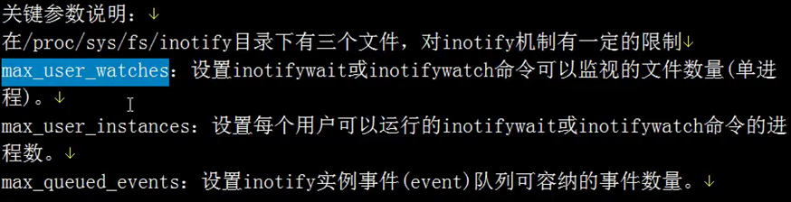

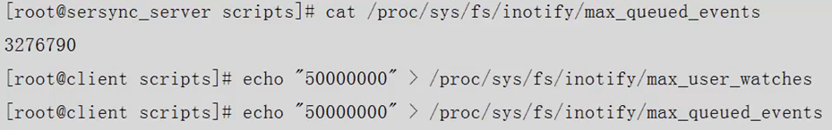

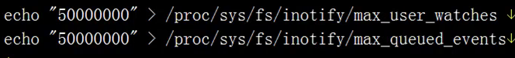

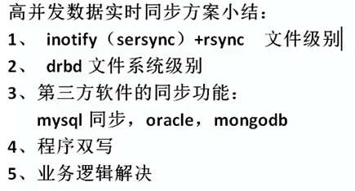

# 案例

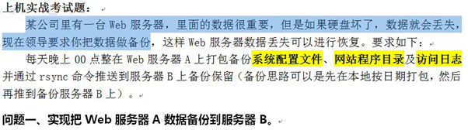

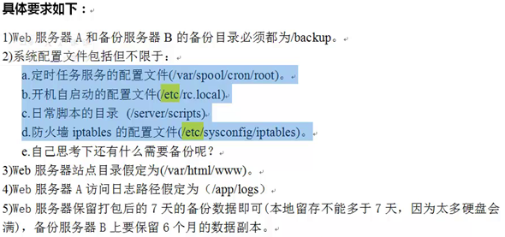



## 备份服务器端准备 （参见前文第一章第不2节）

## Web服务器端文件打包

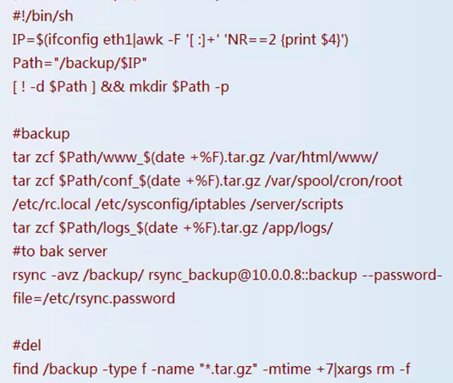

## 配置定时任务

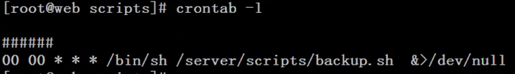

超过180天的删除



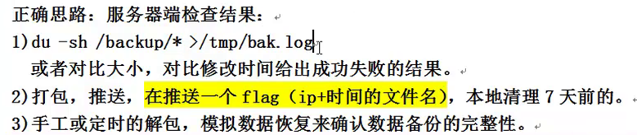

文件比对：



